Leandro,

Sorry about the trouble. The loud noise and the description of bad layer separation indicate the issue centers around the tilting and peeling action.

Steps to check

1.

Remove the the Platform cover on page 30 of

https://docs.google.com/presentation/d/1yzSxYxJ2hDWH5Tks4eD-P5XpEBOaRhRxpic4mbyX3ks/edit?usp=sharing

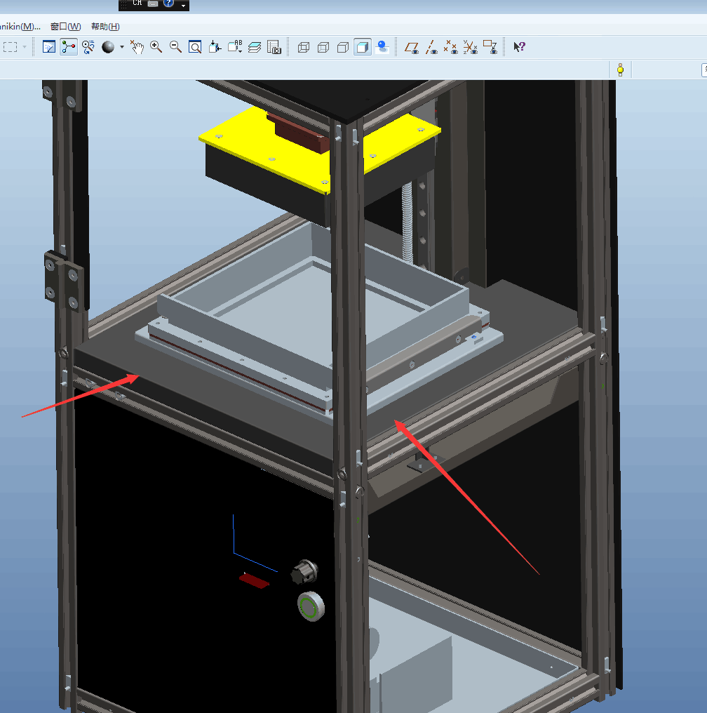

Run a test print with gcode at<https://drive.google.com/open?id=0Bzke6lBHG_z5ajN6VU1scll6QTQ>

Best do not use resin.

See if the sounds still persists, if then check

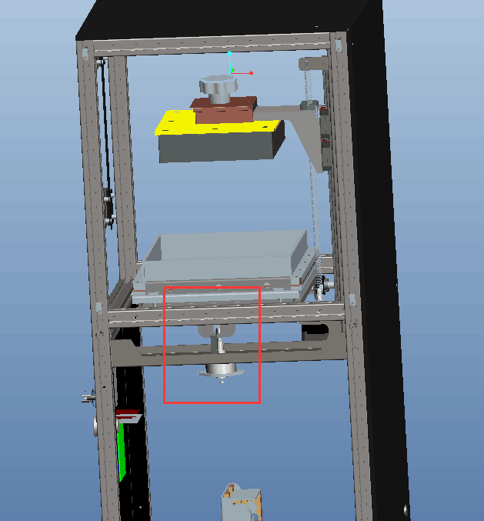

The most common problem centers around the little silver block and pm motor. I think we cover this and you said it is good. Just checking every key step:

On page 24. Make sure the silver metal is secured from below and from the side.

https://docs.google.com/presentation/d/1yzSxYxJ2hDWH5Tks4eD-P5XpEBOaRhRxpic4mbyX3ks/edit?usp=sharing

And it is straight like this

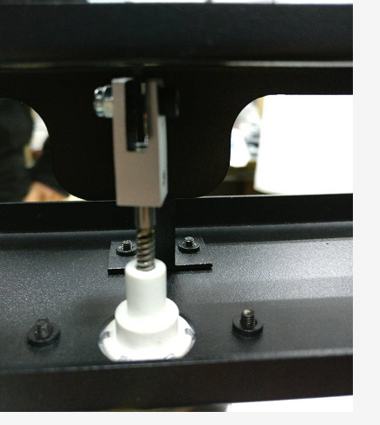

This is most frequent source of the problem.

-

And also check movements here:

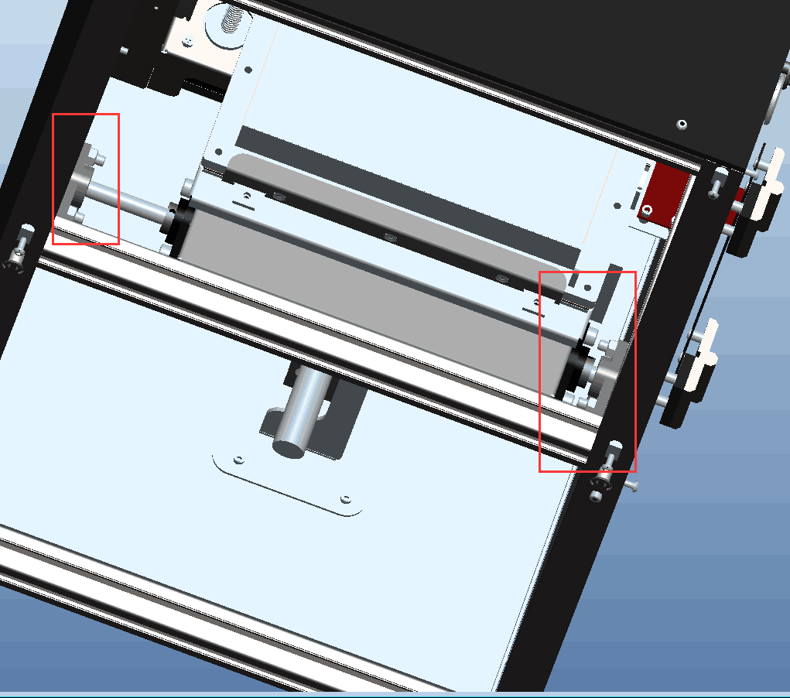

And see if it is secured and not moving holding platform in place while vat tiles.

If you are not sure, film both 2 silver brackets and the pm motor while the print is running and show us that.

The ultimate test is to remove pm motor and the metal hook and move the platform up down and see if you can reproduce the noise. If not, then we will replace the pm motor as the rod may have been damaged

-

An additional note is that your Cura and profiles may be outdated based on your Facebook pictures and comments. Infill should be 70%:

Uninstall your current Cura. *Please delete this directory before installing*

C:\Users\"username"\AppData\Roaming\cura

And then install this

**Latest Cura:**

[https://drive.google.com/open?id=0Bzke6lBHG_z5cjJPNHdXaFZrWWM37](https://drive.google.com/open?id=0Bzke6lBHG_z5cjJPNHdXaFZrWWM)